**10 web server attacks**

1. Denial-of-service (DoS) attacks and Distributed denial-of-service (DDoS) attacks attempt to make a web server unavailable to legitimate users by flooding it with traffic. This can be done by sending a large number of requests to the server, or by using a botnet to control multiple computers to send requests. 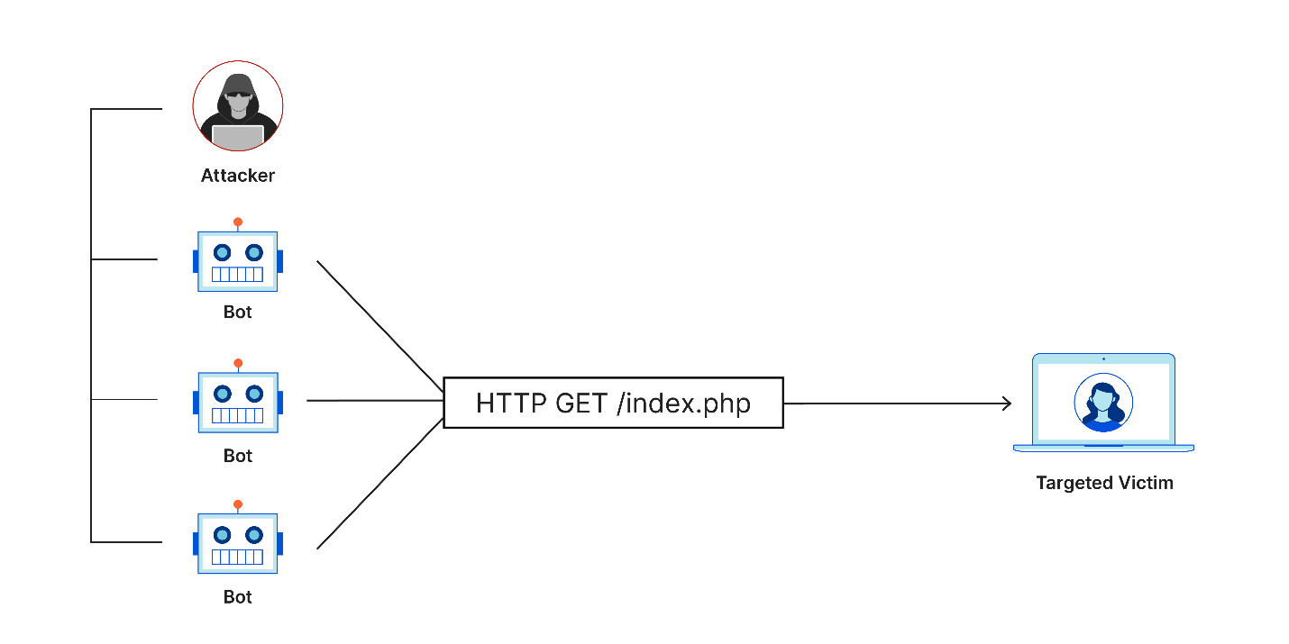
2. Cross-site scripting (XSS) attacks inject malicious code into a web page that is then executed by the victim's browser. This code can steal cookies, session tokens, or other sensitive information. 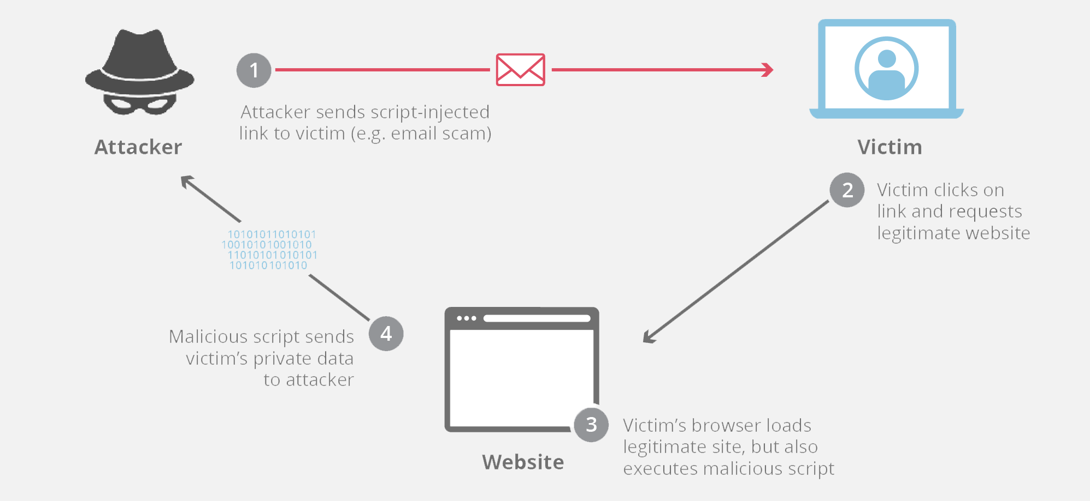
3. SQL injection attacks exploit vulnerabilities in a web application's database to inject malicious SQL statements. These statements can be used to steal data, modify data, or even take control of the database server.

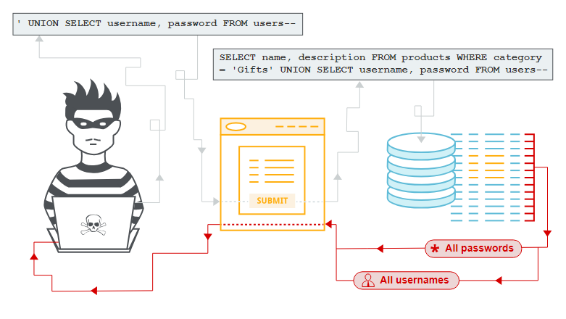

1. Directory traversal attacks exploit vulnerabilities in a web application's file permissions to access unauthorized files or directories. This can be used to steal sensitive files, such as source code or customer data.
2. Man-in-the-middle (MITM) attacks intercept communications between a web server and a client. This allows the attacker to read, modify, or even drop traffic.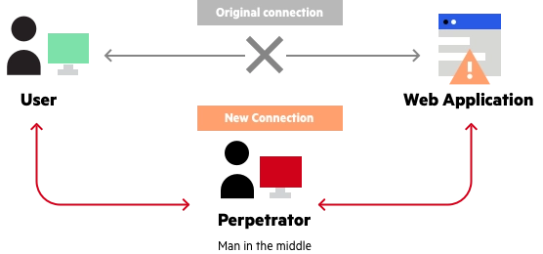
3. Session hijacking attacks steal a victim's session token, which allows the attacker to impersonate the victim and access their account.
4. Phishing attacks send emails or text messages that appear to be from a legitimate source, such as a bank or credit card company. These emails or text messages often contain a link that, when clicked, takes the victim to a fake website that looks like the real website. Once the victim enters their login credentials on the fake website, the attacker can steal them.
5. Malware attacks infect a web server with malicious software. This software can steal data, modify data, or even take control of the server.
6. Zero-day attacks exploit vulnerabilities in software that the software vendor is not aware of. These attacks are very difficult to defend against because there is no patch available.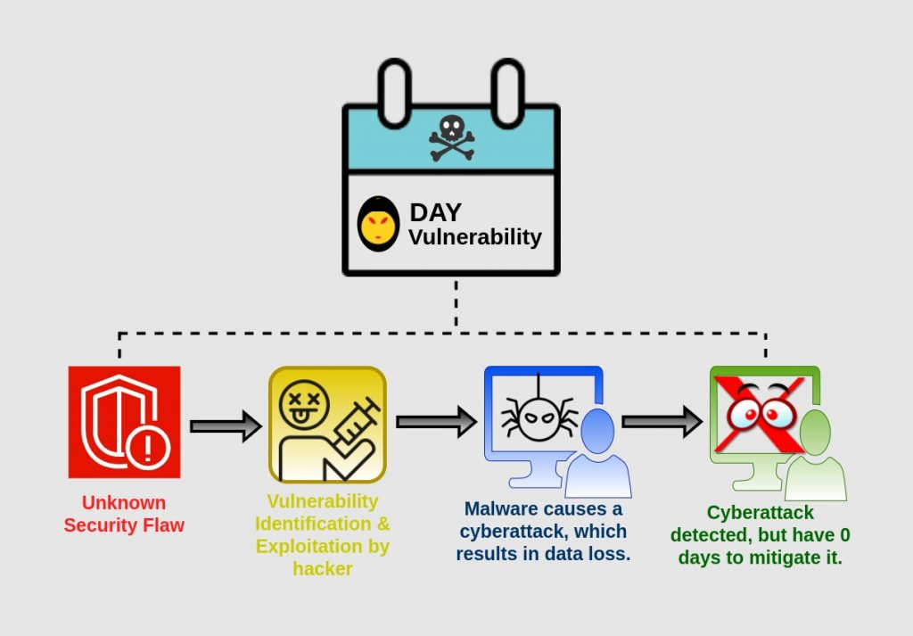
7. Ransomware attacks encrypt a victim's files and demand a ransom payment in order to decrypt them.